**Let's create some CRUD operations**

Now let's learn some basic CRUD  (Create, Read, Update, Destroy) operations for MongoDB. Pay attention to the structure of these queries, as it is quite different than what you're used to (but it is still cohesive). You won't use raw MongoDB syntax in development very much, but all the tools built on top of MongoDB are built with these basic building blocks in mind.

**CREATE - Inserting a document into a collection:**

// Pattern: db.COLLECTION_NAME.insert({YOUR_JSON_DOCUMENT}) // Example: db.ninjas.insert({name: "Trey", belt: "black", status: "awesome"})

Notice that what we're doing is basically JavaScript. The format of the document (BSON object) going into the database is **exactly**the format it will be available to you coming back out of the database. Get comfortable using this syntax by inserting a bunch of things into your collections.

**READ - Retrieving documents from a collection:**

To retrieve documents from your collections, you will use the following method.

// Pattern: db.COLLECTION_NAME.find({YOUR_QUERY_DOCUMENT})

The parameter we pass to this method is a document. Everything in the document will match the fields in the database and only those documents that match the query document will be returned back from the query. Here's an example using the ninja document we just made.

// Example: db.ninjas.find({name: "Trey"})

**Here is what the result should look like:**

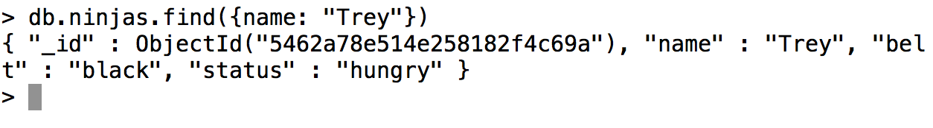

MongoDB by default returns as many results as it can. If you want to just find **all** of the given collection, you can pass an**empty object** to the **.find** method; or you can just not pass anything at all.

// Examples: db.ninjas.find({}) db.ninjas.find()

**Here are the results:**

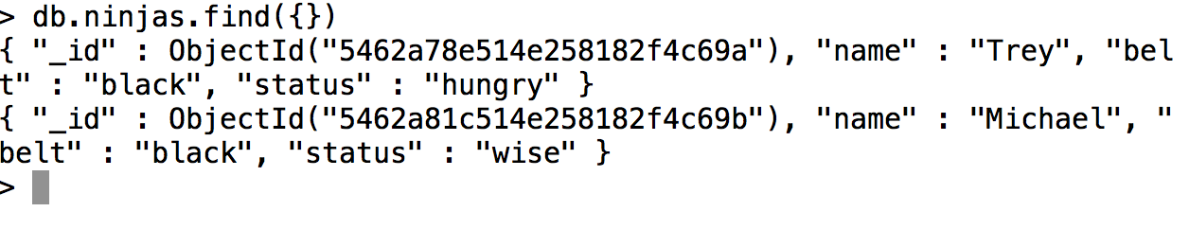

If you want to make the results look nicer and be easier to read:

// Example: db.ninjas.find().pretty()

Result:

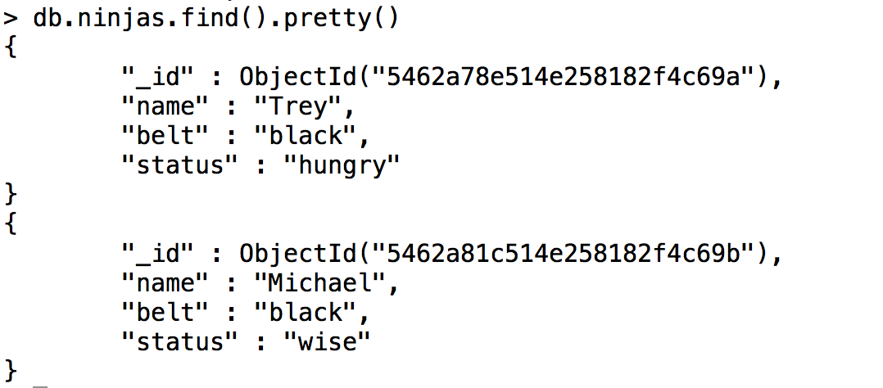

If you noticed, there is a field called **_id** on both records we put in the database. That is the MongoDB **ObjectId,** which MongoDB will **automatically** make for you if you do not specify a value for *_id*. To query by*id*, you have to do the following:

// Example: db.ninjas.find({_id: ObjectId("5462a78e514e258182f4c69a")}) // Notice: You can't just pass the string of characters, you must pass it as an ObjectId.

**HINT:** if you want to sort by something like **creation time** in MongoDB, you can **sort** by *ObjectId* because it is made by using a time stamp as part of the string.

**DESTROY - Removing documents from a collection:**

To remove an item from the database, we would run the following syntax:

// Pattern: db.COLLECTION_NAME.remove({YOUR_QUERY_DOCUMENT}, BOOLEAN) // Example db.ninjas.remove({belt: "yellow"}) db.ninjas.remove({belt: "yellow"}, false) // this query would have the same effect as the one above.

The query document is everything you want the deletion targets to match. The second parameter is a **boolean**, and it is **OPTIONAL**. If the parameter is **omitted**, it defaults to **false**. The boolean is called the**justOne** boolean, and **if it is present and it is true, the remove query will only remove the** **first** **document that matches the query**. Play around with this if it confuses you.

**UPDATE - Updating documents in a collection:**

The *update* syntax can be tricky if you do not see it done correctly first. Let's say I wanted to add a location to the ninja whose name is Trey. I want to make his location equal to Mountain View. I would try to the following:

// Example: db.ninjas.update({name: "Trey"}, {location: "Mountain View"})

Then, to check to make sure if my update query was right, I'd run:

// Example: db.ninjas.find({location: "Mountain View"}).pretty()

Result:

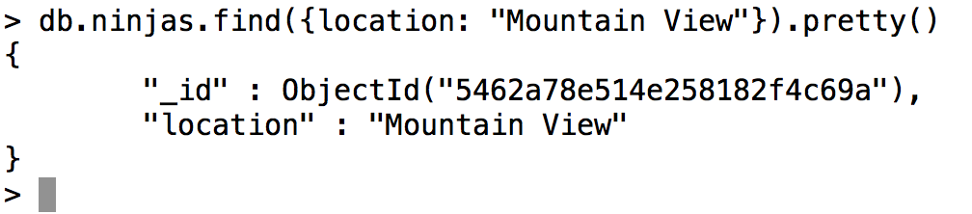

This is an important lesson to learn. Even though the query erased most of the data for this document, the syntax for the update statement was correct. We pass two documents to the method: the first one is the query document, meaning that any document that will get updated must match the query. The second document is the document that contains the fields we want to add. The full syntax for the update query is this:

// Pattern: db.COLLECTION_NAME.update({QUERY}, {FIELDS_TO_UPDATE}, {OPTIONS}) // Note: the options document is optional

MongoDB's native update method will completely overwrite everything **except** the _id field when we run the way shown above.  If we wanted to run the update to only add to the document, (not overwrite it) we would run the following (let's pretend we didn't run the query that erased all of our data):

// Example: db.ninjas.update({name: "Trey"}, {$set: {location: "Mountain View"}})

By default, the update method updates **the first document that matches the first parameter passed to the function**. In this case, it was the first object whose **name** key had a value of "Trey". The **second parameter** in the desired query contains what is called an **update operator**. There are several different types of operators in MongoDB, and we will go over the most common later in the chapter.